The likely stakeholder mapping is presented as follow:

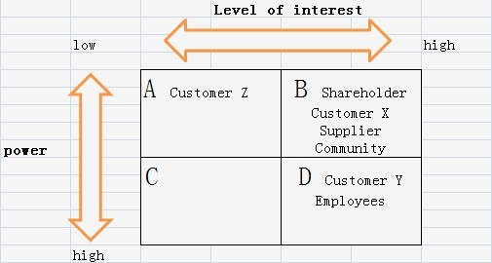

First of all, due to large amount of customers of Starbucks, customers are divided into three types: people who are strongly in favor of the strategy (customer X), people who are largely hostile (customer Y) and people who do not care the strategies of Starbucks (customer Z). Apparently, both customer X and Y have strong interest on strategies while customer Y pretends to have much more power than customer X, for instance, through lobbying or demonstrations. And because customer Z doesn’t care about Starbucks, they have both few interest and power on Starbucks. Secondly, employees should be the key players to strategies. Thirdly, shareholders have great interest on strategies but have limited power because of the separation of ownership and management.

In my opinion, the preferred situation of stakeholder mapping should be:

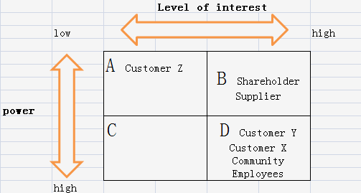

Starbucks could take some measures to change the stance of specific stakeholders to a more optimistic one and to enhance the power of them. For instance, customer X can be stimulated to bolster the proposed strategy and help Starbucks by supplying media access, or even convincing customer Y that the change can be good. Also, if community, which represents the attitude of local people to Starbucks, could be shifted to group D, it will become one of the important indicators for Starbucks’ decision to locate their stores. Community mainly determines the popularity and acceptability of Starbucks in local, so Starbucks can make use of this truth to gain more benefits by increasing connection with customers and community.

Starbucks could decorate digital picture frames in all stores and upload local customer photos and perhaps even family photos of them. Digital picture frames are able to hold thousands of pictures which would turnover regularly throughout all day. It doesn’t cost much, since major amendment to any stores is not required. It would have an immediate effect on improving the family atmosphere, because Starbucks gives people an opportunity to personalize their local coffee store and join a community. The royalty of customer and community can be received through this strategy.

As for new entrants who may offer higher price for supplier in the coffee bean industry, Starbucks should adopt reward system for their suppliers to remain their royalties. For example, they can offer coffee bean farmer a higher price than market price in case the coffee bean is of high quality, which can encourage farmers to improve the quality of coffee bean and remain royalty to Starbucks. They may also ensure good living conditions of farmers and ecological environment of production, such as paying wages to farmers on time, preventing child labor, ensuring their children to receive education, funding to protect local environment.

For cultural and political issues in foreign countries, I suggest that Starbucks could do more survey, for example, deliver questionnaire to local people, to find out whether Starbucks are welcomed by local people and what is the attitude of local people towards Starbucks. Additionally, they need to have a good understanding of the culture and history of foreign countries about whether Starbucks coffee shop fits into them. Reflecting from the combat of entry into brail market and opposition of Chinese about entry into the Forbidden City in Beijing, Starbucks can have a negotiation with the local government or join in the local coffee shop union to seek for legal protection before entry, so that they won’t be resisted by unlawful method.

Benefits for employees

Full-time employees

Part-time employees

life insurance

dental

vision

Paid vacation

Retirement plan

Life insurance

dental

vision